NATIONAL UNIVERSITY OF MODERN LANGUAGE ISLAMABAD
Lab # 02


Submitted to:
Ms. Saadia Shabbir
Submitted by:
Zulqarnain Hassan (SP21379)
Ehsan Mehmood (SP21371)
Subject: …………………… Web engineering
Department: ……………… BSSE-5-Afternoon
Date: ……………………… 25-09-2024

Task 01
Build a simple Web page using Notepad or Notepad++ With a specific title. Your web page must have:
a. An image file.
b. A description about the image.
c. Some Description about the title.
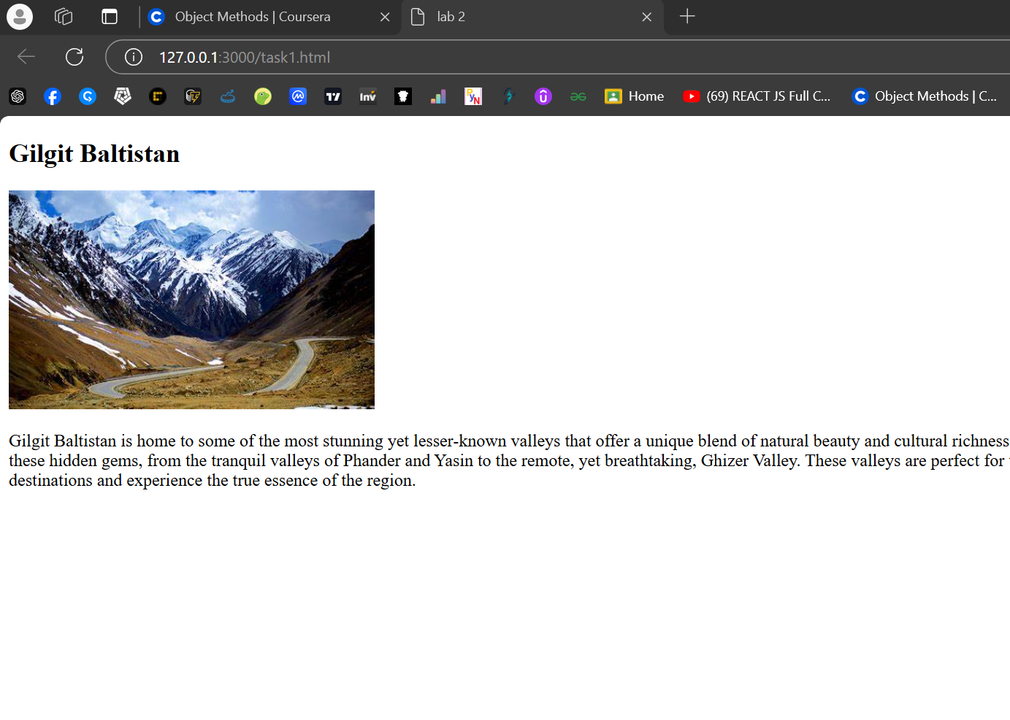

Task 02
Open Code Inspection via Developer tools. Experiment around different Web pages and look to it via changing styles. Note: make 2 to 3 scenarios on customizing web pages and also tell what happens and what are the results.
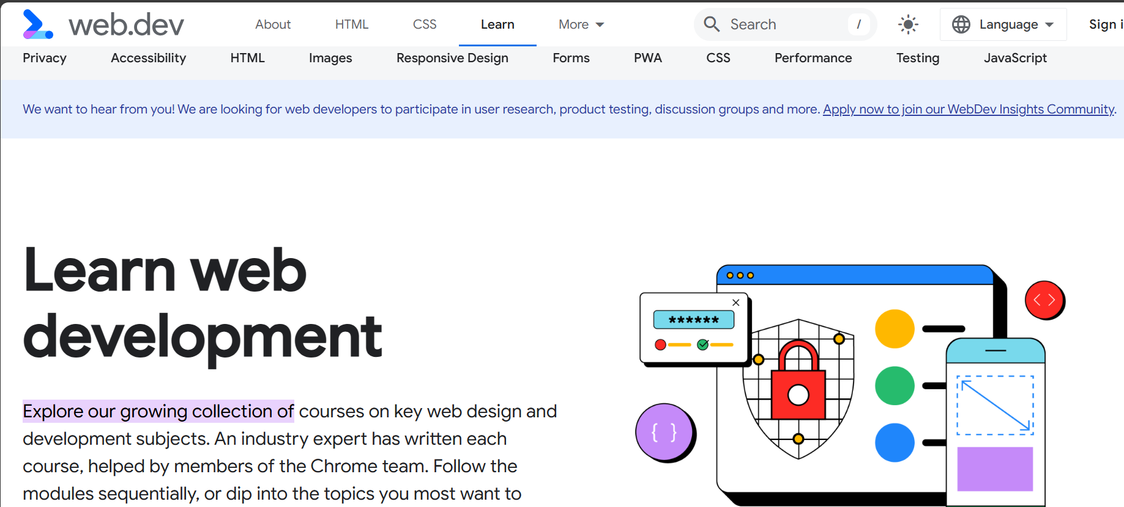

I have made some changes in above page such as Background Color, Text, Font size and imag.
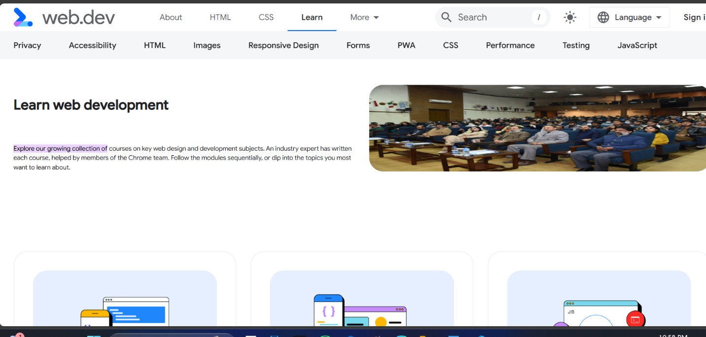

Task 03
Explain the output of following code with reasoning and also list down the errors in it
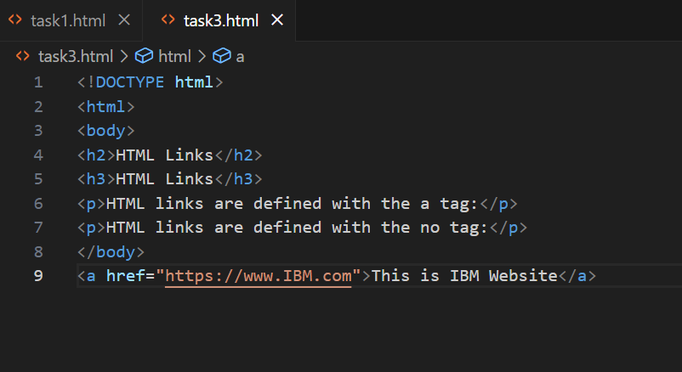

Following was the output on running above code.
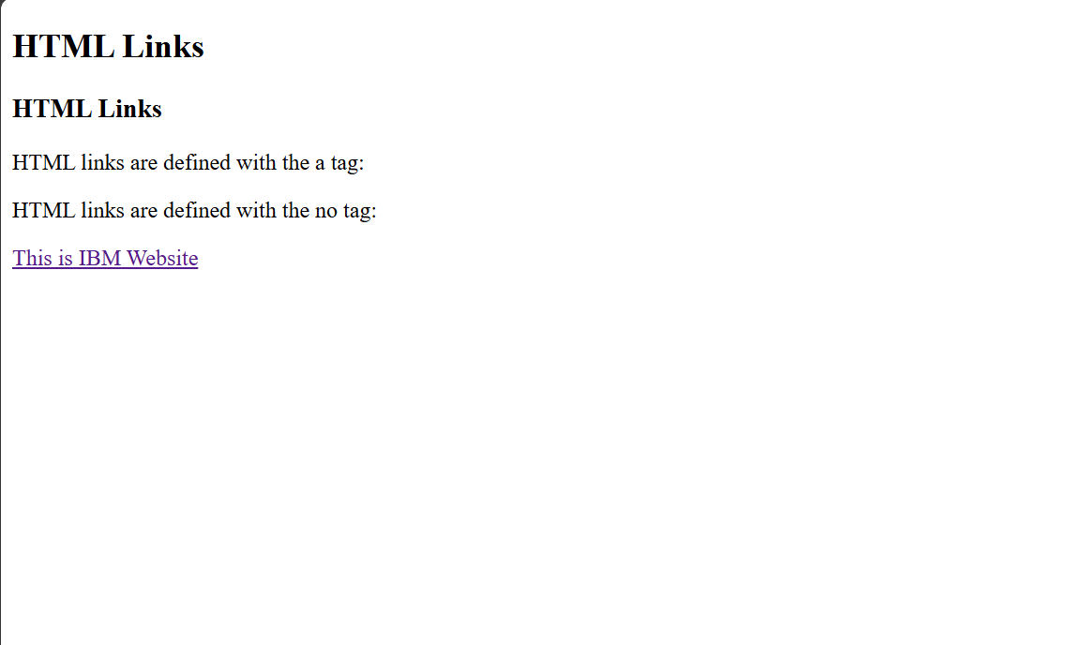

Errors in the code.
- Html closing tag is missing.
- Anchor tag should be inside the body tag.
- Head tag also missing.

